https://www.youtube.com/watch?v=bWA-pZJrOFE – questpond , kudvenkat also good
JWT Token

Token based authentication

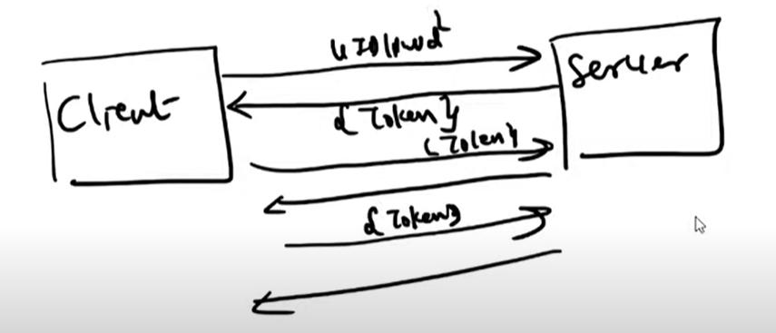

Token – username , claims , algorithm , secretkey , expiration , issuer , created

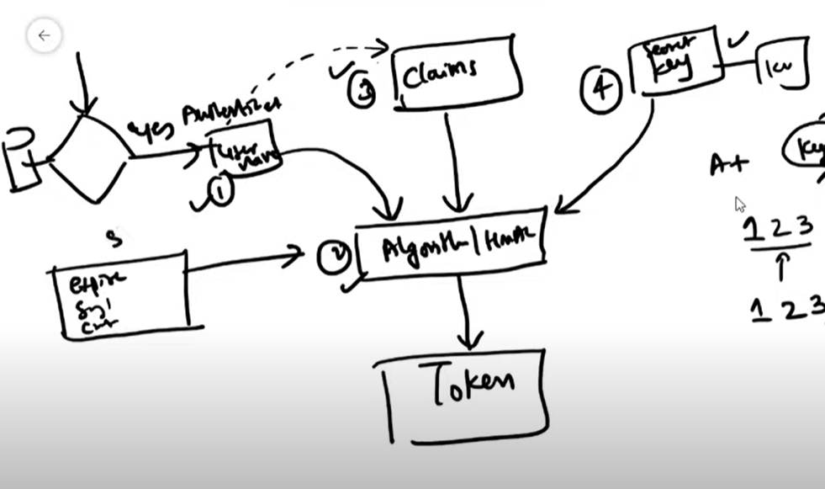

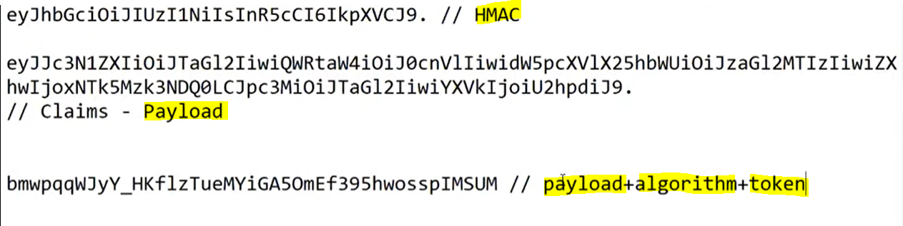

Package : Microsoft.AspNetCore.Authentication.JwtBearer

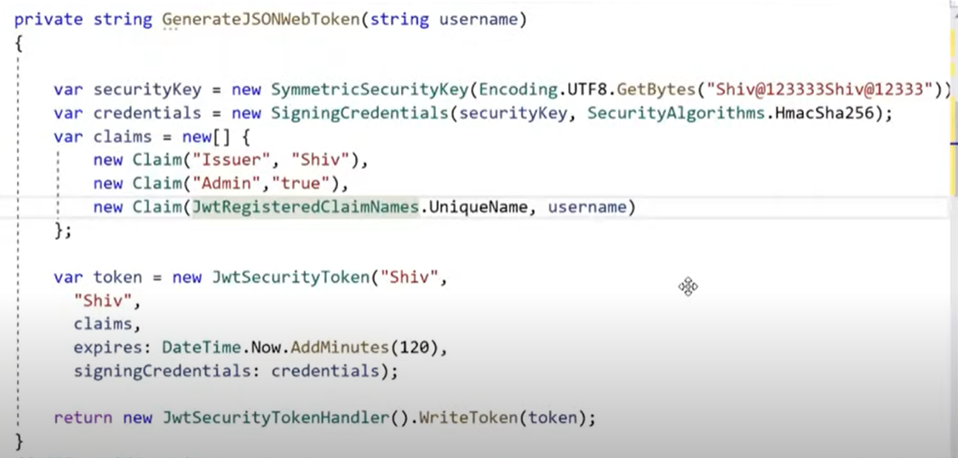

Middleware

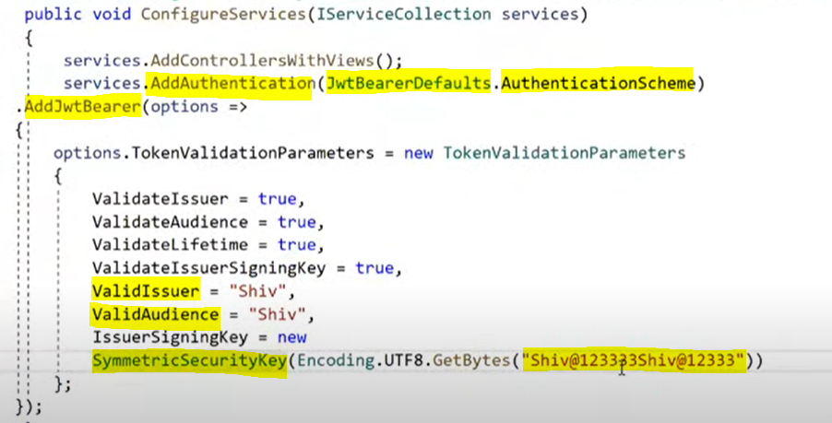

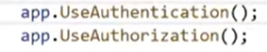

Token has to be sent in a header

Authorization : Bearer {token}

